

Sakura V2

Functional Design Document
  - Submitted

Revisions
Version | Date | Author | Change Summary
1.0 | 05.08.2025 | O. Ozturk | Initial Version

Signoffs
Stakeholder | Date | Status | Comments
Kate Rudwick | 08.08.2025 | Awaiting Approval
Nico Benga | 08.08.2025 | Approved pending observations in comments | See comments in document
Nitin Menon | 08.08.2025 | Awaiting Approval
Safraz Hakamali | 08.08.2025 | Awaiting Approval
Ken Lovingood | 08.08.2025 | Awaiting Approval
Patrick Sura | 08.08.2025 | Awaiting Approval

Contents
1. Overview 3
1.1. Purpose of This Document 3
1.2. Scope of the Application 3
1.3. Architecture Diagram 3
1.4. Intended Audience and User Roles 5
1.5. Key Definitions 5
1.6. Workspace Specific RLS Requirements 10
1.6.1. [TBW] Requirements of FUM 10
1.6.2. Requirements of GI 10
1.6.3. Requirements of CDI 11
1.6.4. Requirements of WFI 12
1.6.5. Requirements of EMEA 14
1.6.6. Requirements of AMER 16
2. Functional Details by Role 18
2.1. Requester Role 18
2.1.1. Requesting Access 18
2.1.2. Viewing Existing Access 23
2.1.3. Notifications & Emails 24
2.2. Approver Role 25
2.2.1. Types of Approvers 25
2.2.2. Approval Flow 25
2.2.3. My Approvals Page 26
2.2.4. Approval Detail Page for an Individual Request 26
2.2.5. Approval of an Individual Request via Email 27
2.3. Workspace Admin Role 27
2.4. Sakura Support Role 28
2.5. Sakura Administrator Role 29
3. Common Functionality 30
3.1. Delegations 30
3.2. Traversing The Approver Tree Based on Security Dimension Attributes 30
3.3. Auditing and Logging 31
3.4. Excel Export 32
3.5. Access using OKTA and MS Entra 32
3.6. Data Sharing with External Parties 32
3.7. Data Imports for Security Dimensions 33
3.8. Emailing and Notifications 33
3.9. In-App Help 34
3.10. Revocation 35
4. Out of Scope 35
5. Assumptions, Risks, and Constraints 41
5.1. Assumptions and Constraints 41
5.2. Risks 42
6. Appendix 43
6.1. Glossary And Acronyms 43
6.2. Diagrams 43
6.2.1. Access Request Flow 43
6.2.2. Role Permission Matrix 44
6.3. Signoff References 45

Overview

Purpose of This Document
The purpose of this document is to define the functional design of the Sakura application. It outlines the intended behavior of the system from a business and end-user perspective, detailing the roles, workflows, features, and rules that govern how access requests are submitted, approved, and managed.
This document serves as a common reference point for stakeholders, including product owners, developers, testers, and administrators. It captures functional expectations to ensure that the implementation aligns with the defined access control objectives, user experience requirements, and operational boundaries of Sakura.

Scope of the Application
Sakura is a self-service authorization management portal designed for users within the dentsu organization to request, approve, and manage access to Power BI reports and datasets. It supports both Object-Level Security (OLS) and Row-Level Security (RLS) across multiple delivery contexts, including Standalone Reports, Workspace Apps, and App Audiences.
The application covers the full request lifecycle: from report/audience selection and access configuration to multi-step approval flows involving Line Managers, OLS Approvers, and RLS Approvers. It also includes role-based administration, audit logging, delegation, in-app help, and email notification features.
Sakura does not manage user access directly within Power BI. Instead, it centralizes access request logic and approval workflows, and shares finalized permission outputs with downstream systems through database views.

Architecture Diagram
The architecture of Sakura V2 consists of several integrated components within the dentsu Azure and VPN environment. Each component plays a specific role in supporting access request workflows, data integration, and system operations.
Sakura Portal
The user-facing web application where end users submit access requests and approvers review and take action on them.
Okta + Azure AD
The identity providers used for user authentication and access control. All users must log in using their corporate credentials before accessing the Sakura Portal.
Users
All authorized dentsu users who can log into Sakura to request access, approve requests, or manage administrative configurations.
Virtual Machine (Azure VM)
The compute environment where the Sakura application and supporting services run.

Sakura Database (Azure SQL)
The central database that stores all metadata related to access requests, user roles, approvals, audit logs, and configuration.
ETL (Azure Data Factory)
Responsible for transferring Security Dimension Data from external systems into the Sakura Database.
Enterprise Data Platform (Microsoft Fabric)
Provides Security Dimensions to Sakura, such as organizational hierarchies, client lists, and other RLS-relevant structures.
In return, Sakura sends Approved RLS Requests back to EDP, which can be used for further data access control or downstream processing.
OLS Manager (Custom .NET Application)
A utility interface used for managing object-level security mappings such as report-to-audience relationships or manual overrides.
Email Dispatcher (Custom .NET Application)
Handles email notifications for request submissions, approvals, rejections, and several other user-facing system actions.
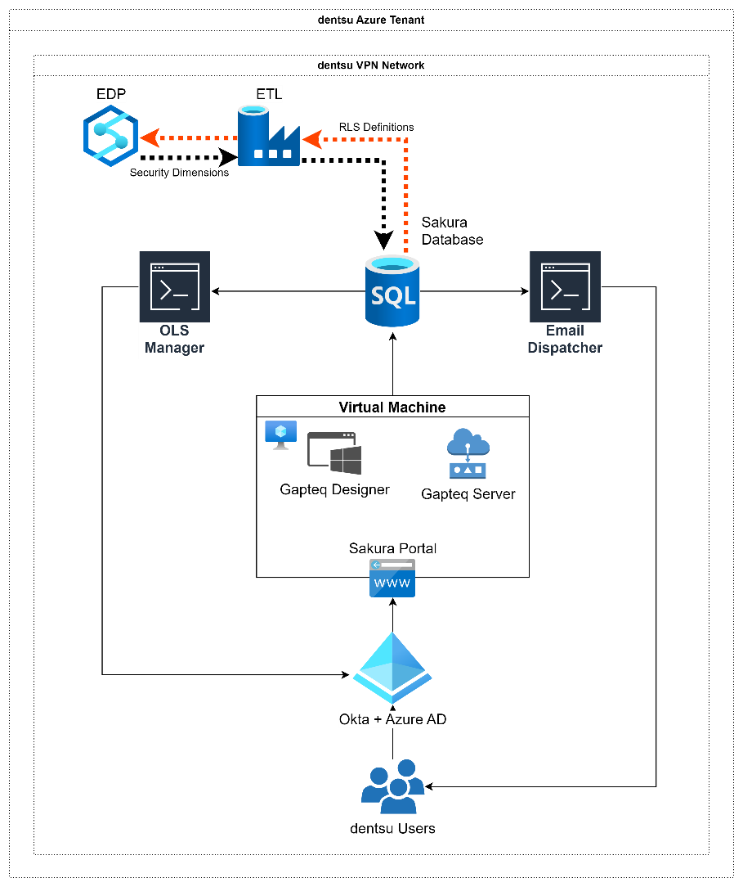
Figure 1 - Architecture Diagram

Intended Audience and User Roles
Role | Description
Requester | End user requesting access
Approver | Reviews and approves/rejects access requests
Workspace Admins | Manages security models, approvers and object definitions within a Workspace
Sakura Support | Handles questions, technical issues, and helps users resolve blockers
Sakura Administrator | Configures the system, manages settings, automation, and audit features as well as Workspaces and Security Dimensions.

Key Definitions
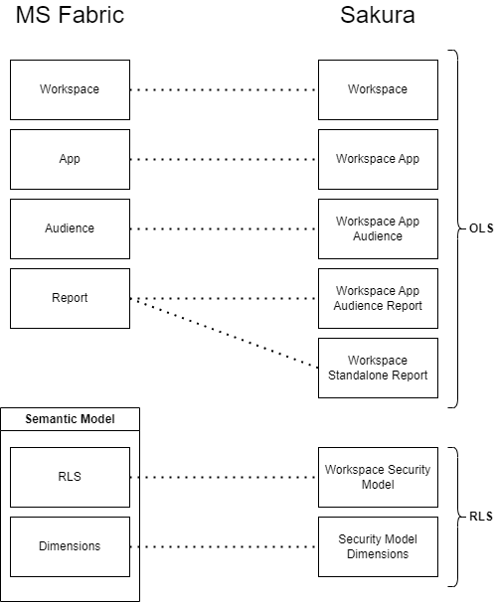
Figure 2 - Virtual Equivalents of Objects in Sakura and MS Fabric

Sakura is a system designed to manage both Object-Level Security (OLS) and Row-Level Security (RLS) within Power BI environments. Its architecture introduces a layer of abstraction over Microsoft Fabric concepts, enabling centralized and user-friendly access control. Below are the core concepts of Sakura, structured around OLS and RLS components:
The first and foundational OLS component in Sakura is Workspace. This corresponds directly to the Microsoft Fabric concept of a Power BI Workspace, which holds various analytical assets, including reports, datasets, applications, and associated security configurations. In Sakura, a workspace serves as the container that governs all security relationships and structures.
The second key OLS component is the Workspace App. Within a single Workspace, multiple Workspace Apps can be created. These mirror Power BI Apps in Fabric, which are essentially briefcases of reports grouped for a specific business need.
In Sakura, each Workspace App is further subdivided into Workspace App Audiences, which represent user groups that are granted visibility into specific reports. These are functionally equivalent to Power BI App Audiences in Fabric. Each Audience includes one or more reports made available to that group.
From Sakura’s perspective, there are two types of reports: Workspace Standalone Reports (SAR) and Workspace App Audience Reports (AUR). Technically, both types are simply Power BI reports stored in a workspace. However, they are differentiated by how they are shared with users. If a report is shared directly with users without being packaged in an App, it is categorized as a SAR. If it is distributed through an App and linked to an Audience, it is considered an AUR.
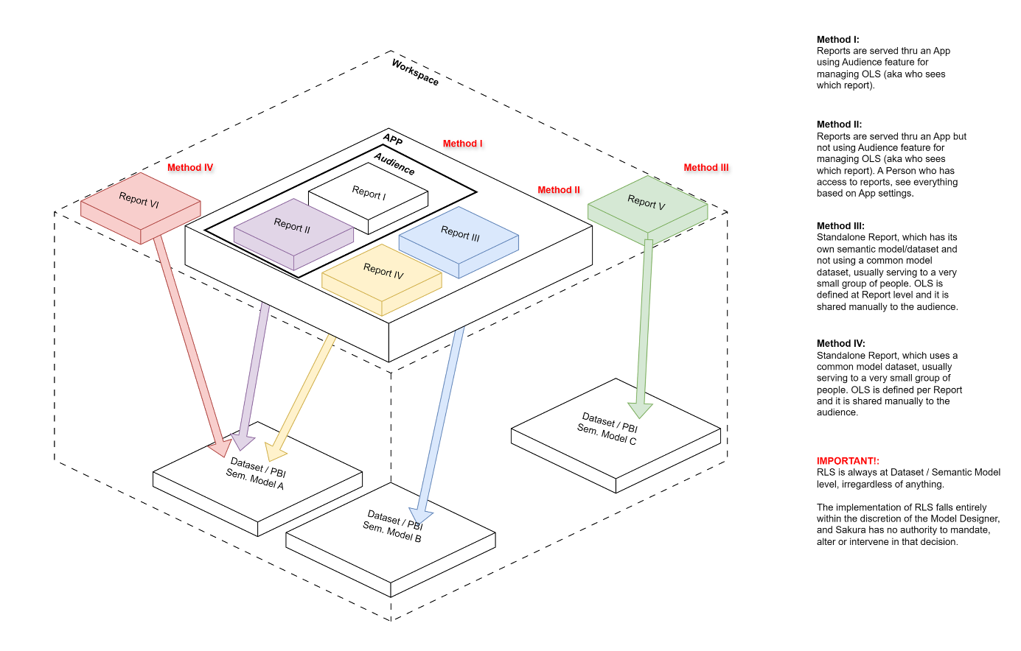
Figure 3 - Report Delivery Scenarios and Methods
Beyond OLS, Sakura also manages RLS (Row-Level Security) components. The central concept here is the Workspace Security Model. This defines how RLS is structured within a Workspace, based on which dimensions (i.e., business attributes) are applied to filter data visibility. A Workspace may contain multiple semantic models (datasets), and each model may either share or have distinct RLS configurations. For example, a Finance Workspace might contain both “FIN” and “OFR” semantic models. If both models rely on the same RLS dimension tables in the data warehouse, Sakura allows them to share a single Workspace Security Model. This simplifies user access management by preventing the need for duplicate access requests across multiple models.
The final building block of RLS in Sakura is the Security Model Dimension. These are the actual dimensions (such as Country, Brand, or Department) used within a semantic model to define access filters. In Microsoft Fabric, these correspond to the dimensions within the dataset used for RLS filtering. In Sakura, they are modelled and managed explicitly as part of the Workspace Security Model to allow for fine-grained and auditable access control.

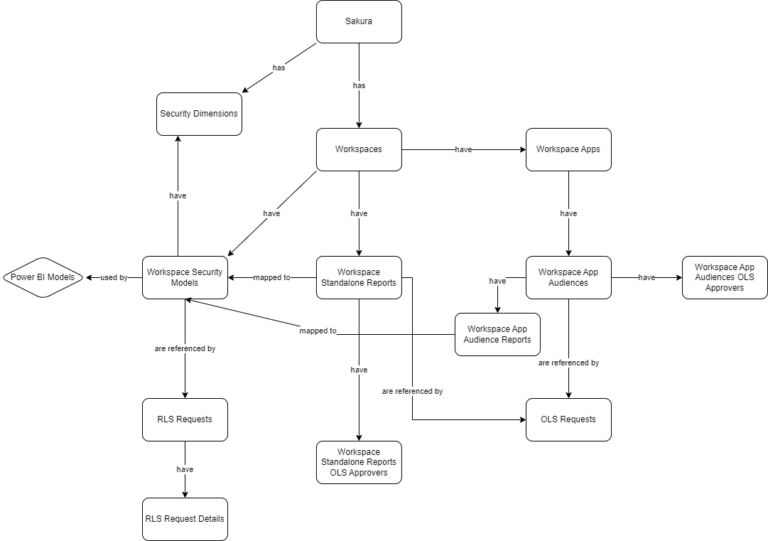
Figure 4 - ER Diagram of Sakura Key Elements

  - Workspaces
The foundational unit in Sakura represents a Power BI Workspace. It holds all analytical components such as reports, datasets (semantic models), security models, and Workspace Apps. It is the starting point for both OLS and RLS configurations in Sakura.
Currently there are following workspaces available in dentsu:
Fabric Workspace | Owner(s) | PBI Model | UMS Data Domain | PBI Designer | DWH Designer
DFI Workspace | Kate Rudwick / Terry Newell | FUM | Finance | Vitali/ Yadava | Sumon/ Sean
Growth Insights Workspace | Nico Benga | Growth Insights Model | Growth Insights | Vitali/ Yadava | Amit
CDI Workspace | Nitin Menon | CDI Model | Not Applicable | Yadava | Sean
Workforce Workspace | Safraz Hakamali | Workforce Model | Workforce, Timesheet | Alok | Alok
AMER Workspace | Ken Lovingood | ACM | Not Applicable | Pradeep | Dhiraj
EMEA Workspace | Patrick Sura | EMEA market-specific models | Not Applicable | Alex (CE)  Sara (FR)  Simon (NOEUR) | Alex

  - Workspace Apps
A container within a workspace in Sakura, equivalent to a Power BI App in Microsoft Fabric. Each Workspace App groups a collection of reports for a specific business purpose and is the main distribution method for reports to end users.
  - Workspace App Audiences
A grouping of reports within a Workspace App. Each audience represents a distinct view configuration within the app, defining which reports are visible to which group of people. Audiences do not define the users themselves but instead define sets of reports that certain people are allowed to see.
  - Workspace Reports
Workspace Reports refer to all Power BI reports hosted within Workspace in Sakura, classified based on how they are delivered to end users. There are two main types:
- Workspace Standalone Reports (SAR): These reports are shared directly with users without being included in any Workspace App. They are handled individually within Sakura’s object-level security model and represent a direct access scenario. (See Method III & Method IV in Figure 2 - Report Delivery Scenarios and Methods.)
- Workspace App Audience Reports (AUR): These reports are included within a specific Audience of a Workspace App and are delivered to users via that App structure.
  - Workspace Security Model
A structure that defines the RLS (Row-Level Security) logic for a given Workspace. It specifies which dimensions are used for filtering and how they apply to the semantic models within the Workspace. If multiple semantic models share the same RLS setup, a single Workspace Security Model is reused across them to avoid redundant access configurations.
  - Security Dimensions
Business dimensions (such as Entity, Service Line, Brand) that are used to slice data in semantic models via RLS. In Sakura, these dimensions form the backbone of the Workspace Security Model and control which rows of data a user can see based on their assigned values.
  - RLS Requests
These are access requests initiated by end users based on a given Workspace Security Model and its associated Security Dimensions. Users specify the values they need access to (e.g., specific regions or brands), and the request is evaluated against the RLS logic defined in that model.
  - OLS Requests
Access requests related to object-level visibility, such as gaining access to a Standalone Report or to a specific App Audience. These requests trigger approval flows based on the target object’s ownership and configuration.
  - RLS Approvers
Designated individuals responsible for reviewing and approving RLS Requests. Their approval authority is typically scoped to specific values within a Security Dimension (e.g., a regional manager approving access to their region’s data).
  - OLS Approvers
Users responsible for approving OLS Requests. Their responsibility depends on the context, for example, a report owner for Standalone Reports or an audience-level approver for reports accessed via App Audiences. The OLS approver logic in Sakura supports both report-based and audience-based ownership models.
  - Report Catalogue
The Report Catalogue is the unified registry of all reports, audiences, and apps across every Workspace within Sakura. It acts as a central access point where users can view what content exists, regardless of their permission status. Each item’s type (report, audience, app) is visually distinguished, allowing for intuitive understanding. The catalogue includes a search function to help users quickly locate content. Additionally, each item is visually marked to indicate whether the user has access, enabling a clear and immediate understanding of visibility rights.

Workspace Specific RLS Requirements
The requirements in this section are based on the original Sakura Security Access – Requirements Document. However, after its finalization, additional alignment meetings were conducted with individual Workspace Owners to further clarify and revise the expectations around Security Dimensions and RLS Workflows.
Each Workspace has unique data structures, governance rules, and access patterns, which require tailored RLS configurations and Wizard UI logic. This section consolidates the finalized requirements into two subsections:
- Security Dimensions: Specifies which business attributes (e.g., Market, Client, Practice Area) should be used to define access control per Workspace and confirm their availability in the UMS data model.
- RLS Dimension Selection Workflow: Describes how access requests should be guided, and the information is collected during the request creation.

[TBW] Requirements of FUM

Security Dimensions

RLS Dimension Selection Workflow

Requirements of GI
Based on the meeting titled “Sakura RLS for GI” held on 21.07.2025 at 15:30 CET, the finalized Security Dimensions for the Growth Insights Workspace are as follows:

Security Dimensions
Dimension | Dimension Attributes | SL/PA Based | MSS Based
BL_UMV.DimEntity | Market -> Cluster -> Region | x | x
BL_UMV.DimClient | Client -> Dentsu Stakeholder | x | x
BL_UMV.DimServiceLine | Service Line (filtered to PAs) | x
BL_UMV.DimMasterServiceSet | L2 -> L1 + Overall |  | x
Security Types: SL/PA, MSS

RLS Dimension Selection Workflow

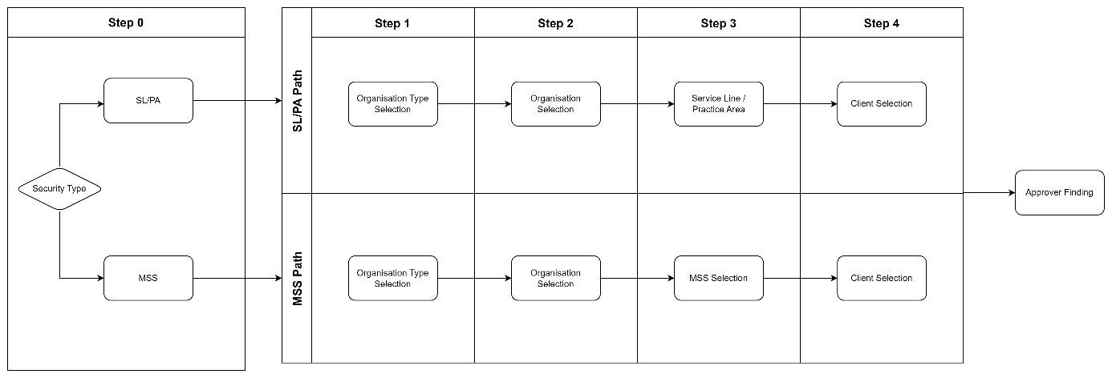
Figure 5 - RLS Workflow for GI Workspace

The RLS request workflow for the Growth Insights Workspace begins with the selection of a Security Type. At this stage, users are presented with two options:
- SL/PA (Service Line / Practice Area)
- MSS (Master Service Set)
Depending on the selected Security Type, the workflow follows one of the two predefined paths. Both paths consist of three steps, differing only in the second step.
SL/PA Path:
- Step 1: Organization Selection. The user is asked to choose an organization level: Market, Cluster, or Region. Based on the selection, the corresponding list is displayed. For example, if the user selects "Cluster", a list of available clusters is shown for selection.
- Step 2: SL/PA Selection. The user is presented with a tree-structured list showing only Practice Areas. After selecting a Practice, the flow continues.
- Step 3: Client Selection. The user chooses between All Clients and Specific Client.
  - If "All Clients" is selected, the process proceeds to the next step.
  - If "Specific Client" is selected, a list of Dentsu Stakeholders is shown, from which the user selects one stakeholder before continuing.
MSS Path
- Step 1: Organization Selection. Identical to the SL/PA path, the user selects one of: Market, Cluster, or Region, and sees the corresponding list.
- Step 2: MSS Selection. The user is shown a hierarchical list of MSS L1 and L2 elements. After selecting the appropriate MSS node, the flow continues.
- Step 3: Client Selection. Same logic as in the SL/PA path: the user selects either All Clients or a Specific Client, which triggers the Dentsu Stakeholder list if applicable.

Requirements of CDI
Based on the meeting titled “Sakura V2 RLS Dimensions for GI Workspace” held on 05.08.2025 at 10:00 CET, the finalized Security Dimensions for the CDI Workspace are as follows:

Security Dimensions
Dimension | Dimension Attributes | CDI
BL_UMV.DimEntity | Legal Entity -> BPC Entity-> Market -> Cluster -> Region | x
BL_UMV.DimClient | Client -> Dentsu Stakeholder | x
BL_UMV.DimServiceLine | Service Line / PA | x

Security Types: CDI (aka no Security Type selection is asked)

RLS Dimension Selection Workflow
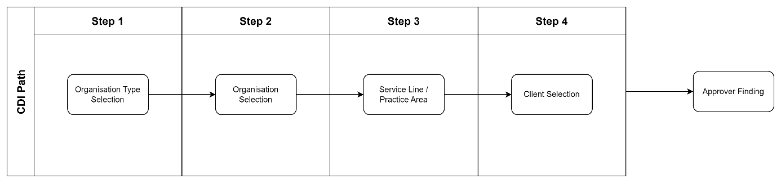
Figure 6- RLS Workflow for CDI Workspace
The RLS workflow for the CDI Workspace is simplified, as it involves only one Security Type. Therefore, there is no initial Security Type selection. Instead, the user is guided through a fixed three-step process to define access across two hierarchical dimensions:
- Step 1: Organization Selection. The user selects a level from Entity, such as Market, Cluster, or Region. Based on the selection, the relevant list is shown. For example, selecting "Cluster" displays the available clusters.
- Step 2: Service Line Selection. The user selects a Service Line or Practice Area from the tree structure.
- Step 3: Client Selection. The user chooses between All Clients and Dentsu Stakeholders.
  - If All Clients is selected, the process continues directly.
  - If Dentsu Stakeholder is selected, a list of stakeholders is shown, from which the user selects one.

Requirements of WFI
Based on the meeting titled “Sakura 2.0 - Workforce Model” held on 23.07.2025 at 15:00 CET, the finalized Security Dimensions for the Workforce Insights Workspace are as follows:

Security Dimensions
Dimension | Dimension Attributes | WFI
[sensitive].[DimPeopleAggregatorNodeWD] | Business Areas > Business Functions | x
BL_UMV.DimEntity | Market -> Cluster -> Region | X

Security Types: WFI (aka no Security Type selection is asked)

RLS Dimension Selection Workflow
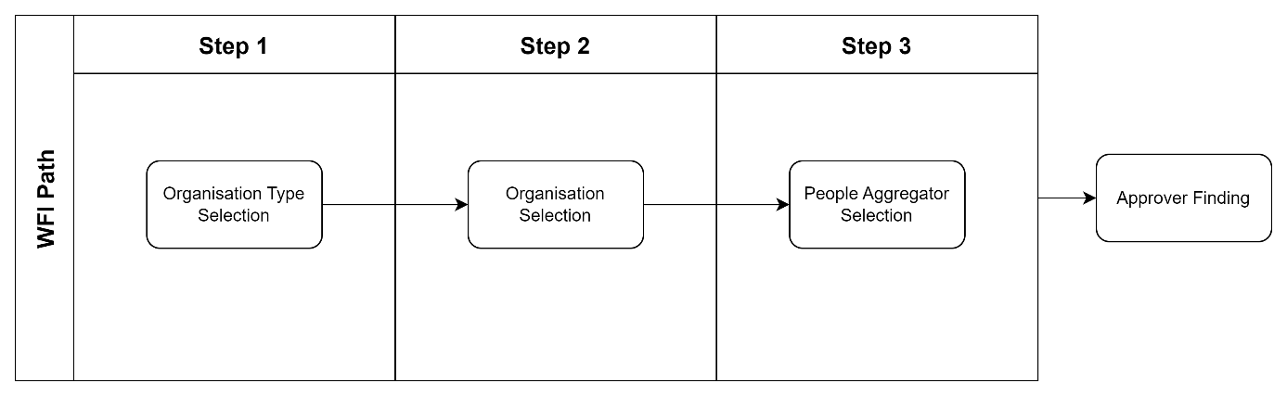
Figure 7 - RLS Workflow for WFI Workspace
The RLS workflow for the Workforce Insights (WFI) Workspace is simplified, as it involves only one Security Type. Therefore, there is no initial Security Type selection. Instead, the user is guided through a fixed two-step process to define access across two hierarchical dimensions:
- Step 1: Entity Selection. The user is asked to choose an organization level: Market, Cluster, or Region. Based on the selection, the corresponding list is displayed. For example, if the user selects "Cluster", a list of available clusters is shown for selection.
- Step 2: People Aggregator Selection. The user is then asked to choose a People Aggregator value from a hierarchical structure which has Business Area and underneath Business Functions, hiding the “No Function” elements from the tree. It should look like this:
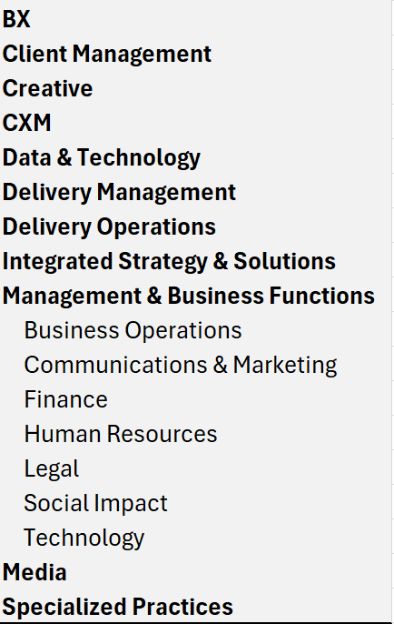
Figure 8 - WFI Wizard People Aggregator Tree View

Requirements of EMEA
Based on the weekly regular meeting held on 25.07.2025 at 10:00 CET, the RLS configuration for the EMEA Workspace follows a multi-path structure, where the user begins by selecting one of five Security Types. Each Security Type corresponds to a distinct sequence of dimension selections, as outlined below.

Security Dimensions
Dimension | Dimension Attributes | Orga | Client | CC | Country | MSS
BL_UMV.DimEntity | Legal Entity ->  BPC Entity ->  Market ->  Cluster ->  Region ->  Global | x | x | x |  | x
BL_UMV.DimServiceLine | Service Line -> Overall | x | x | x | x
BL_UMV.DimClient | Client -> Dentsu Stakeholder -> All |  | x
BL_UMV.DimCostCenter |  |  |  | x
BL_UMV.DimCountry | Country-> Cluster->  Region ->  Global |  |  |  | x
BL_UMV.DimMasterServiceSet | L4 -> L3 -> L2 -> L1 - Overall |  |  |  |  | x

Security Types: Orga – SL/PA, Client, CC, Country, Orga - MSS

RLS Dimension Selection Workflow
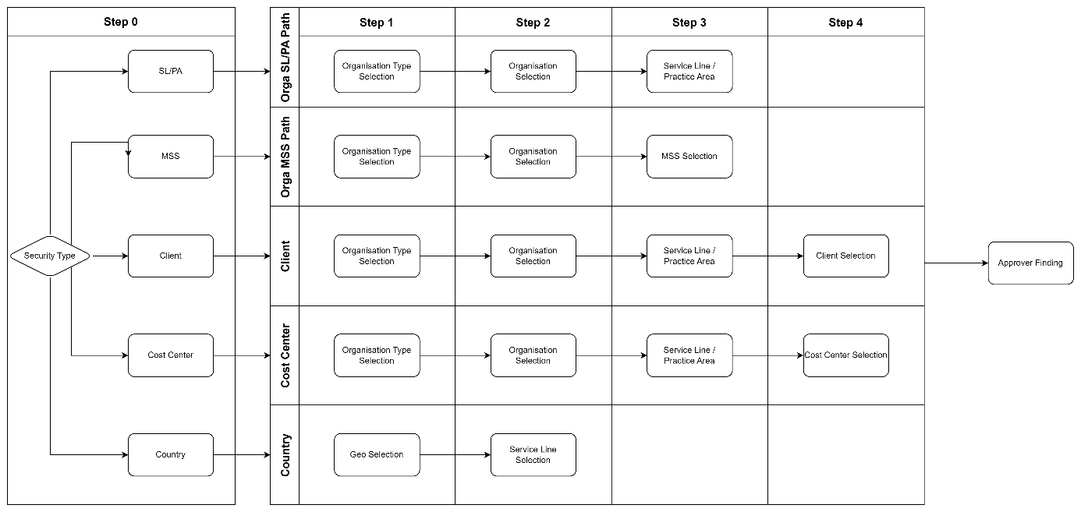
Figure 9 - RLS Workflow for EMEA Workspace
The RLS request workflow for EMEA Workspace begins with the selection of a Security Type. At this stage, users are presented with two options:
- Orga - SL/PA (Service Line / Practice Area)
- Client
- CC
- Orga - MSS
- Country
Depending on the selected Security Type, the workflow follows one of the two predefined paths. Both paths consist of three steps, differing only in the second step.
Orga – SL/PA Path:
- Step 1: Organization Selection. The user selects a level from Entity, such as Market, Cluster, or Region. Based on the selection, the relevant list is shown. For example, selecting "Cluster" displays the available clusters.
- Step 2: Service Line Selection. The user selects a Service Line or “Overall” from Service Line tree.
Client Path:
- Step 1: Organization Selection. The user selects a level from Entity, such as Market, Cluster, or Region. Based on the selection, the relevant list is shown. For example, selecting "Cluster" displays the available clusters.
- Step 2: Service Line Selection. The user selects a Service Line or “Overall” from Service Line tree.
- Step 3: Client Type Selection. The user chooses between All Clients and Dentsu Stakeholders.
  - If All Clients is selected, the process proceeds to the next step.
  - If Dentsu Stakeholder is selected, the user is shown a list of stakeholders to choose from.
- Step 4: Client Selection. The user selects a stakeholder from the list (if applicable).
CC (Cost Centre) Path:
- Step 1: Organization Selection. The user selects a level from Entity, such as Market, Cluster, or Region. Based on the selection, the relevant list is shown. For example, selecting "Cluster" displays the available clusters.
- Step 2: Service Line Selection. The user selects a Service Line or “Overall” from Service Line tree.
- Step 3: Cost Center Selection. The user selects a Cost Center from the tree. The content of the tree changes based on the previous selection of Organization. For Levels upper than Legal Entity in Organization selection, only BPC Rollups will be shown. Single Cost Center and Business Unit elements are only available on Legal Entity level because they are legal entity specific.
MSS Path:
- Step 1: Organization Selection. The user selects a level from Entity, such as Market, Cluster, or Region. Based on the selection, the relevant list is shown. For example, selecting "Cluster" displays the available clusters.
- Step 2: MSS Selection. The user navigates the hierarchy in MSS (L1 to L4) and selects an MSS value.
Country Path:
- Step 1: Country Selection. The user selects a level from Geo Hierarchy, such as Country, Cluster, or Region.
- Step 2: Service Line Selection. The user selects a Service Line or “Overall” from Service Line tree.

Requirements of AMER
Based on the meeting titled “Sakura 2.0 - AMER implementation” held on 28.07.2025 at 14:00 CET, the finalized Security Dimensions for the AMER Workspace are as follows:

Security Dimensions
Dimension | Dimension Attributes | Orga | Client | CC | PC
BL_UMV.DimEntity | Legal Entity -> BPC Entity-> Market -> Cluster -> Region ->Global | x | x | x | x
BL_UMV.DimServiceLine | Service Line -> Overall | x | x | x | x
BL_UMV.DimClient |  |  | x |  | x
BL_UMV.DimProfitCenter | Profit Center -> Brand - All |  |  |  | x
BL_UMV.DimCostCenter |  |  |  | x

RLS Dimension Selection Workflow
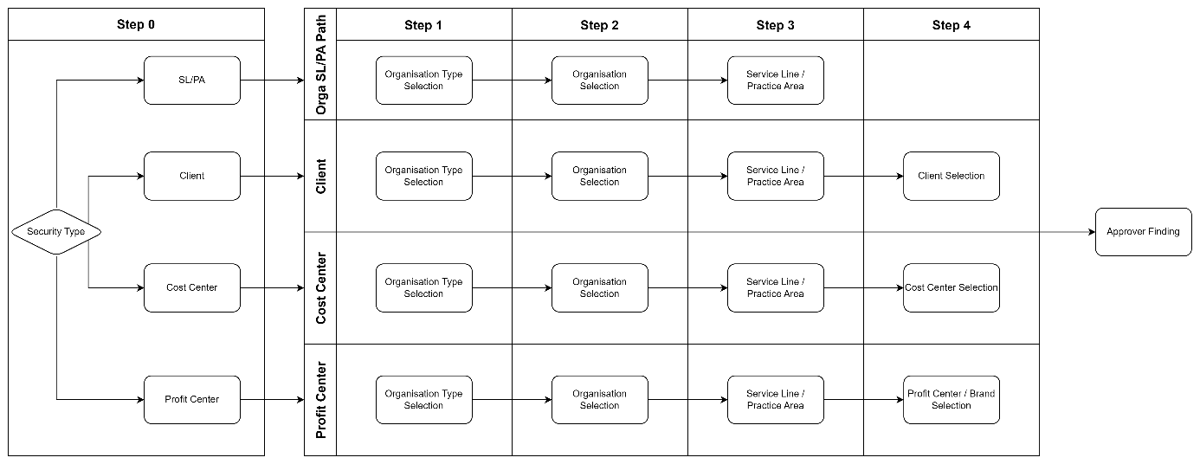
Figure 10 - RLS Workflow for AMER Workspace
The RLS request workflow for the AMER Workspace begins with the selection of a Security Type. At this stage, users are presented with two options:
- Orga
- Client
- CC
- PC
Depending on the selected Security Type, the workflow follows one of the two predefined paths. Both paths consist of three steps, differing only in the second step.
Orga – SL/PA Path:
- Step 1: Organization Selection. The user selects a level from Entity, such as Market, Cluster, or Region. Based on the selection, the relevant list is shown. For example, selecting "Cluster" displays the available clusters.
- Step 2: Service Line Selection. The user selects a Service Line or “Overall” from Service Line tree.
Client Path:
- Step 1: Organization Selection. The user selects a level from Entity, such as Market, Cluster, or Region.
- Step 2: Service Line Selection. The user selects a Service Line or “Overall” from Service Line tree.
- Step 3: Client Type Selection. The user chooses between All Clients and Dentsu Stakeholders.
  - If All Clients is selected, the process proceeds to the next step.
  - If Dentsu Stakeholder is selected, the user is shown a list of stakeholders to choose from.
- Step 4: Client Selection. The user selects a stakeholder from the list (if applicable).
CC (Cost Center) Path:
- Step 1: Organization Selection. The user selects a level from Entity, such as Market, Cluster, or Region.
- Step 2: Service Line Selection. The user selects a Service Line or “Overall” from Service Line tree.
- Step 3: Cost Center Selection. The user selects a Cost Center from the tree. The content of the tree changes based on the previous selection of Organization. For levels above Legal Entity, only BPC Rollups are shown. Single Cost Center and Business Unit elements are only available on Legal Entity level because they are legal entity specific.
PC (Profit Center) Path:
- Step 1: Organization Selection. The user selects a level from Entity, such as Market, Cluster, or Region.
- Step 2: Service Line Selection. The user selects a Service Line or “Overall” from Service Line tree.
- Step 3: Profit Center Type Selection. The user chooses between Profit Center or Brand.
- Step 4: Profit Center Selection. Based on the previous selection, a list of PCs or Brands is shown for selection.
- Step 5: Client Type Selection. The user chooses between All Clients and Dentsu Stakeholders.
- Step 6: Client Selection. If Dentsu Stakeholder is selected, the user selects a stakeholder from the list.

Functional Details by Role
Each section below details all functionality available to the specific role.

Requester Role

Requesting Access
Sakura offers a structured and intelligent wizard-based interface for end users to request access to Power BI reports and datasets, supporting both Object-Level Security (OLS) and Row-Level Security (RLS). The request process is dynamic and adapts based on the report’s delivery method, existing access, and workspace configuration.

Requesting Access using Report Catalogue
- User Initiates the Request
  - The user begins by searching for a report they need access to using the built-in search functionality from the Report Catalogue.
  - The results will show clearly the type of report (SAR/AUR) and which App that report belongs to.
  - If there are multiple reports with the same name, they will be listed as two items.
- Report Selection
  - The user selects the desired report from the search results.
- System Determines Report Delivery Method
  - Sakura checks how the selected report is delivered:
    - Standalone Report
    - Audience Report (distributed via a Workspace App)
- Branch 1: Standalone Report
  - The system checks if the user already has access.
    - If access exists, the user is prompted whether they only want to change the RLS.
      - If “Yes”, the process continues with RLS steps.
      - If “No”, the wizard ends.
    - If access does not exist, Sakura identifies the OLS approver and proceeds.
- Branch 2: App Audience Report
  - The system finds all audiences associated with the report and lists them.
    - If multiple audiences are available, the user selects one.
  - The system checks if the user already has access to the selected audience.
    - If access exists, the user is asked if they only want to change the RLS.
      - If “No”, the wizard ends.
    - If access does not exist, the system proceeds with OLS steps.
  - Sakura finds the applicable OLS Approver and stores the OLS permission in memory.
- Security Model Selection
  - The system lists all Security Models for the selected Workspace.
    - If only one model is found, Sakura auto-selects it.
    - If multiple models exist, the user chooses the desired one.
- Check Existing RLS Access
  - Sakura checks if the user already has RLS access to the selected Security Model.
    - If access exists, the user is asked if they would like to reuse existing RLS.
      - If “Yes”, the wizard skips to summary.
      - If “No”, proceed with custom RLS definition.
- Security Type Selection
  - The system lists available Security Types for the selected model.
  - The user selects a Security Type.
- Security Dimension Selection
  - Based on the selected Security Type, Sakura displays relevant Security Dimensions.
  - The user selects values from each dimension as needed.
- Approver Detection
  - Sakura attempts to find an RLS Approver matching the selected combination of dimension values.
    - If no approver is found, the wizard ends.
    - If found, the request proceeds.
- Summary & Confirmation
  - Sakura displays a summary view showing:
    - OLS and RLS request details
    - Any previously granted access.
  - The user clicks Finish to submit the request.
- Request Finalization
  - The system creates the RLS and/or OLS permissions as needed and stores the request in the system.
  - Approval flow is triggered accordingly (Line Manager → OLS Approver → RLS Approver).

Requesting Access in Advanced Mode
Sakura’s Advanced Mode offers a more direct way for experienced users to submit access requests when they already know the technical structure of the Workspace, App, Audience, or Report they need access to. Unlike the Report Catalogue mode, this path allows users to bypass catalogue-driven discovery and instead to select the OLS and RLS request contexts directly.
- User Initiates Advanced Request
  - From the Requests menu, user selects New Request (Advanced).
- Workspace Selection
  - The system displays a list of available Workspaces.
  - User selects the Workspace they want to access.
- Object Selection
  - User is asked to define the scope of access:
    - Workspace App + Audience
    - or a Standalone Report (SAR)
- Delivery Method Logic
  - Based on the selection:
    - If the selected item is a SAR, the system checks for existing access to that report.
    - If it is an Audience, system checks if the user already has access to that Audience.
- Access Evaluation
  - If access already exists, users are asked whether they want to request only RLS changes.
    - If user selects “No,” the wizard ends.
    - If “Yes” or access does not exist, process continues.
- OLS Approver Detection
  - System finds the relevant OLS Approver.
  - OLS permission is stored in memory and process moves to RLS steps.
- Security Model Selection
  - The system lists all Workspace Security Models related to the selected object.
  - If only one exists, it is selected automatically.
  - If multiple, users choose one.
- Check for Existing RLS Access
  - The system checks if the user already has access to the selected model.
  - If yes, the user is asked if they want to use the existing RLS record.
    - If yes, wizard proceeds to summary.
- Security Type and Dimension Selection
  - User selects the Security Type.
  - System loads the related Security Dimensions.
  - User chooses the required dimension values.
- Approver Lookup
  - Sakura tries to find the RLS Approver for the selected combination.
  - If no approver is found, the wizard ends.
  - If found, wizard proceeds.
- Summary and Finalization
  - The system shows a summary screen with OLS and RLS request information.
  - User clicks Finish.
- Submission and Approvals
  - The system creates OLS and RLS permission requests.
  - Standard approval flow begins: Line Manager → OLS Approver → RLS Approver

Other Request Wizard Functionalities
Can Submit Multiple Access Requests (OLS or RLS)
Sakura does not restrict users from submitting multiple access requests for the same workspace. A user can submit:
- Multiple OLS requests (e.g., for different reports or audiences)
- Multiple RLS requests (e.g., for different security dimension combinations)
- Or any combination of both
Each OLS or RLS request is treated as a separate and independent access request. Accordingly, each one triggers its own approval workflow.
During approval, approvers will be able to see the requester’s existing access rights within the same workspace.
“Help Me” Option for Unsure Requesters
At any step in the request wizard, users who are unsure how to proceed can click the “Help me” button located on the page.
Depending on the context of the step:
- If the step already involves a known Workspace, the help request is automatically forwarded to the corresponding Workspace Owner. They are responsible for reviewing the help request and guiding the user accordingly.
- If the wizard step occurs before a Workspace has been determined (e.g., report search, before selection), the system forwards the help request to GoTo, prompting the user to create a Sakura App Support Case for further assistance.
This feature ensures that users do not get stuck or abandon their request due to uncertainty, while routing the request to the right responsible party based on where they are in the flow.
Request on Behalf of Another User
During one of the steps in the request wizard, the user is asked whether the access request is being created for themselves or on behalf of someone else.
- If the request is being created for another person:
  - The user submitting the request is recorded as Requested By
  - The person the request is intended for is recorded as Requested For
- If the request is for the user’s own access, both values (Requested by and Requested For) are set to the same user.
This functionality is particularly useful in onboarding scenarios where a buddy or line manager (LM) initiates access requests for a new joiner.
Wizard Workflow Entry Points for Creating Requests (Guided, Advanced)
Sakura provides multiple entry points for users to initiate access requests, depending on their level of certainty and familiarity with the report structure.
There are two primary modes for creating requests, accessible via the Requests menu:
- New Request (Using Report Catalogue): This is the Guided mode. It walks the user step by step through the access request process, starting from report selection and proceeding through delivery method, OLS, and RLS definitions. For details, see section 2.1.1.1 Requesting Access using Report Catalogue .
- New Request (Advanced): This mode allows more experienced users to directly select the target Workspace App, or Report and manually define OLS and RLS details. For more on this method, refer to 2.1.1.2 Requesting Access in Advanced Mode.
Additionally, external report catalogues or documentation systems (such as SharePoint, Confluence, or GoTo) can redirect users directly into Sakura’s Guided mode, with a specific report preselected. This is done by appending parameters e.g. reportTag to the URL, which Sakura can use to pre-load the wizard with the correct context.
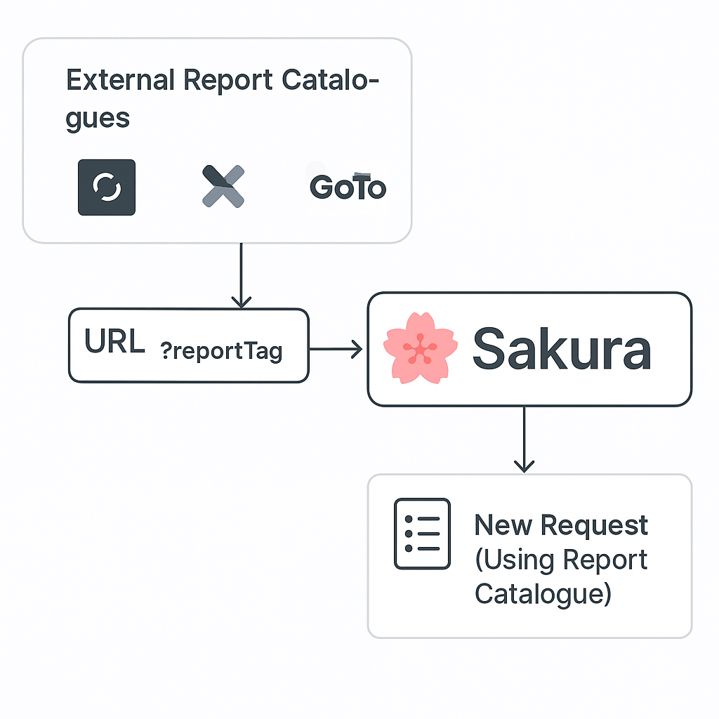
There are no restrictions on how a request should be initiated. Whether launched from within Sakura or from an external tool, users are free to start wherever is most convenient, as long as the necessary identifiers (e.g. reportTag) are provided in the URL.

Viewing Existing Access
Sakura provides two distinct views for users to monitor their current access rights and the history of their access requests:
My Access
- Users can navigate to the My Access section from the main menu to view a list of all access rights currently granted to them.
- This includes both Object-Level Security (OLS) and Row-Level Security (RLS) permissions.
My Requests
- The My Requests section displays access request history where:
  - The user submitted the request for themselves, or
  - The user submitted the request on behalf of someone else, or
  - A request was submitted by someone else on behalf of the user.
- Records are categorized as OLS and RLS, and displayed separately.
Request Details View
- Clicking on any record opens a read-only detail page with:
  - Full request metadata
  - Approval status and audit history
- No actions can be performed on this page. However, contextual links are provided to navigate related items, such as:
  - The relevant Workspace App
  - The associated Audience or Standalone Report (SAR)
  - Linked Security Models for RLS records.
  - Etc.

Notifications & Emails
Sakura keeps requesters informed throughout the lifecycle of their access requests via automated email notifications and in-app alerts.
Email Notifications to Requesters
- Submission Confirmation
  - Immediately after submitting a request, the requester receives a confirmation email including:
    - Request summary
    - Date of submission
    - A Reference for the Request
- Approval Notifications
  - The requester is notified when each approval step is completed (Line Manager, OLS, and RLS).
  - Emails indicate which step has been approved and who approved it.
- Rejection Notifications
  - If the request is rejected at any step, the requester receives an email with:
    - Rejection reason (mandatory field from approver)
    - Step at which it was rejected.
    - Guidance to resubmit if applicable.
- Revocation Notifications
  - If the request is revoked at any step, the requester receives an email with:
    - Revocation reason (mandatory field from approver)
    - Guidance to resubmit if applicable.
- Delegation Awareness
  - If an approver is unavailable and the request is approved by a delegate, the requester is still informed of who approved on their behalf.

Approver Role
Sakura automatically identifies approvers based on their presence in defined approval intersections. Anyone assigned as an approver for any RLS or OLS context is considered an active Approver within the system.

Types of Approvers
There are three types of approval responsibilities within Sakura:
- Line Managers
  - Retrieved dynamically from Workday.
  - Represent the manager of the employee for whom the request was submitted.
- OLS Approvers (Object-Level Security)
  - Defined at the Workspace level for each report, audience, or app, depending on the report’s delivery structure.
  - Maintained by one of the following roles: Workspace Owner, Workspace Technical Owner, or Workspace Approvals Owner.
  - Rules for defining OLS Approvers:
    - For Standalone Reports (when Delivery Mode is not App-WithAudience): approvers are defined in the Workspace Reports section.
    - If the report is part of an App:
      - If the Approval Mode in Workspace Apps is AppBased, the approver is defined directly in the Workspace Apps.
      - If Approval Mode is AudienceBased, the approver is defined in App Audiences.
- RLS Approvers (Row-Level Security)
  - Defined per Security Model and based on Security Dimensions.
  - Configured by Workspace Owner, Workspace Technical Owner, or Workspace Approvals Owner.

Approval Flow
When a new access request is submitted, the system follows this sequence:
- Line Manager Approval
  - An email notification is sent to the requester’s line manager.
  - The line manager must approve before the request proceeds.
- OLS Approver Approval
  - After line manager approval, the OLS Approver receives a notification.
  - The OLS Approver must approve before the request proceeds
- RLS Approver Approval
  - Once OLS approval is completed, the RLS Approver is notified.
  - The RLS Approver must approve before the request finally saved as Approved.

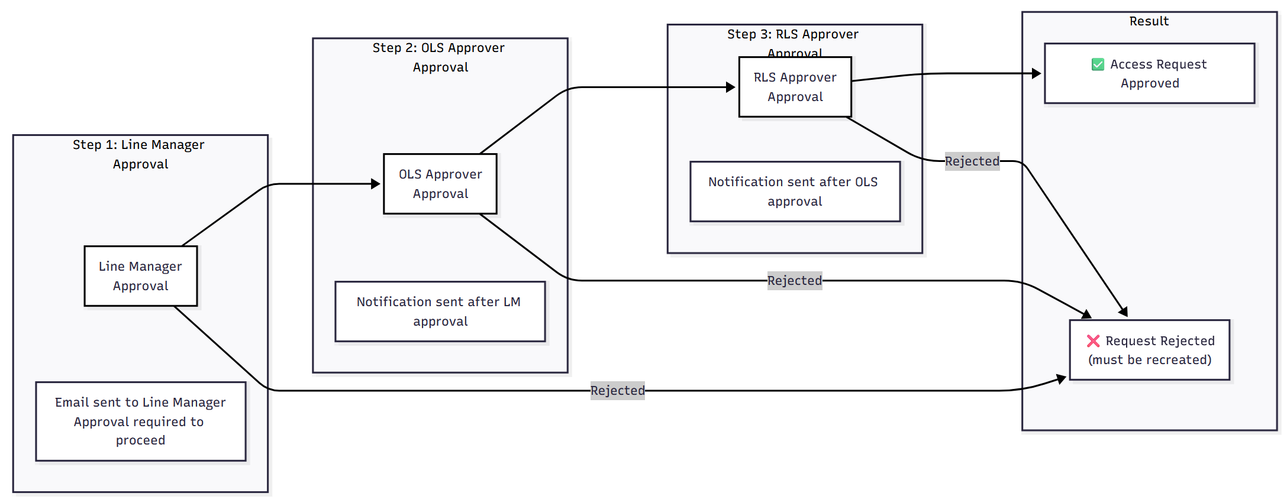
Figure 11 - Approval Process
Each step must be approved in sequence. At every stage, approvers receive email notifications with direct links to the approval task. Sakura also performs security and anti-forgery validations before rendering the approval interface.
During approval, approvers will be able to see the current step and details in a progress timeline of approval sequence.
During approval, approvers will be able to see the requester’s existing OLS and RLS access rights within the same workspace.
Note that: Rejected requests cannot be reopened or approved later. A new request must be created.

My Approvals Page
The My Approvals section is available to all users in Sakura. However, only those who are assigned as an approver for active or historical requests will see entries listed on this page, which includes:
- LM Approvals
- OLS Approvals
- RLS Approvals
Each section provides:
- Filters to switch between Approved and Awaiting Approval requests.
- View-only access to historical approvals assigned to them during their active assignment period (past assignments are not visible)
- Delegated approvals (when active) will also appear here; for more information, see Section “5.1 Delegations”
Actions:
- Approve button to approve selected requests that are awaiting approval.
- Reject button with a mandatory justification message input to reject selected requests that are awaiting approval.
- Revoke button with a mandatory justification message input to revoke selected requests that are awaiting approval (just for OLS and RLS Approvers)

Approval Detail Page for an Individual Request
When accessing an approval page individual request in Sakura UI, the approval page includes:
- Approval Chain Status – displays current state of each approval step.
- Request Details – summarized OLS and RLS request information.
- Existing Rights Overview – brief view of current OLS and RLS access for the user (with links to detailed views in a new tab)
- Approval Actions
  - Approve button.
  - Reject button with a mandatory justification message input.
  - Revoke button with a mandatory justification message input.

Approval of an Individual Request via Email
Sakura will enable approvers to take action on access requests directly via email.
When an approver is assigned to a request (Line Manager, OLS Approver, or RLS Approver), the system sends a notification email that includes:
- Request summary details (user, object, dimensions, etc.)
- A direct “Approve” and “Reject” link.
- Current status of the approval chain
- Optional comments from the requester (if provided)
Upon clicking a link, the system performs the following:
- Validates the identity of the user (via session or login)
- Performs anti-forgery and integrity checks to prevent tampering.
- Redirects the user to a secure approval screen preloaded with request context.
Approvers can finalize their decision from this screen. If Reject is selected, a justification message is required before submission.
This feature ensures that approvers can act quickly and securely, even without navigating through the full Sakura interface.

Workspace Admin Role
Users assigned as the Workspace Owner, Workspace Tech Owner to a Workspace by Administrator, are granted administrative capabilities specific to the configuration and management of Workspace elements within the Sakura platform. This role plays a pivotal part in maintaining the underlying security structure and configuring how Sakura acts.
Functional Capabilities:
- Security Model Administration
  - Create and maintain Security Models per Workspace
  - Define the logic and associations that drive authorization.
- Security Dimension Management
  - Define and configure Security Dimensions for each Workspace.
  - Maintain mappings between Security Dimensions and Security Models
- Standalone Report Management
  - Add or edit Standalone Reports within Workspaces
  - Deactivate outdated or deprecated reports.
  - Map reports to appropriate Security Models
- App & Audience Management
  - Register and manage Apps published from Workspaces.
  - Create, edit, and deactivate App Audiences
  - Map App Audiences to relevant Security Models
- App Audience Report Management
  - Associate individual reports with App Audiences for contextual delivery.
- Approver Configuration
  - Assign and manage Object-Level Security (OLS) Approvers
  - Assign and manage Row-Level Security (RLS) Approvers for each dimension intersection.
- Revocation of Access Requests
  - Revoke existing OLS or RLS access requests that fall under their respective Workspaces.
  - This applies to permissions that were previously approved and are still active.
All actions are performed via an administrative UI with appropriate validations, and every change is subject to audit tracking for compliance and traceability.
A Workspace Owner will be simply responsible for defining the following components in their workspace:
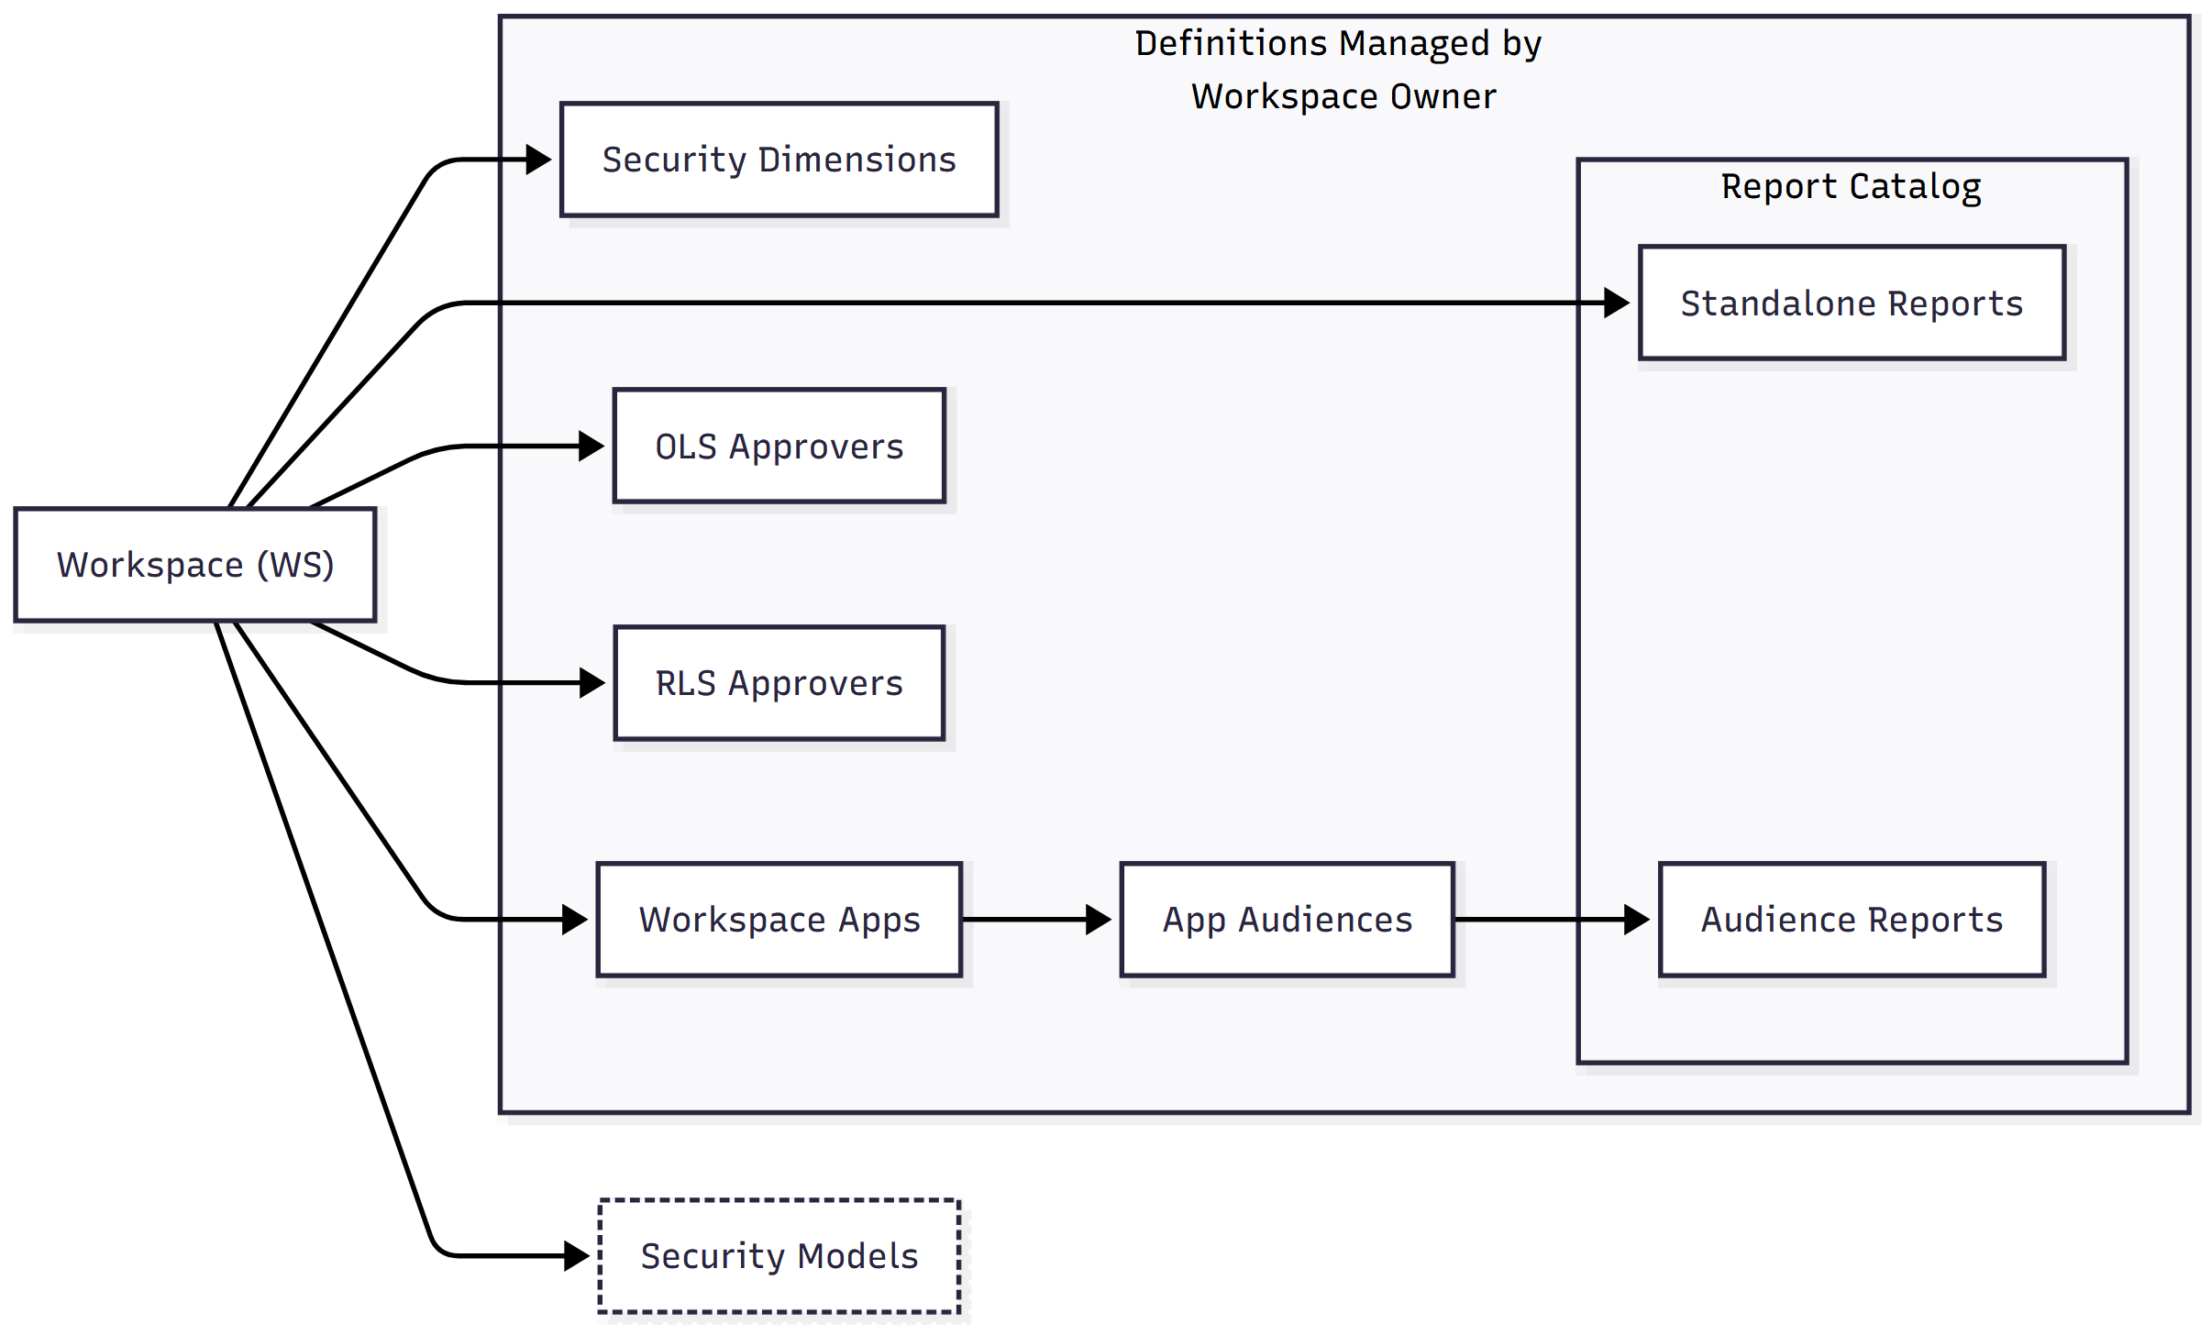
Figure 12 - Components that are configured by WSA

Sakura Support Role
The Sakura Support role is designed to provide visibility into the system for assistance purposes without the ability to modify any data. This role is strictly read-only, ensuring that support personnel can investigate issues and guide users in support cases.
Functional Capabilities (Read-Only)
- Request Visibility
  - View all RLS and OLS Requests in the system.
  - Can not create, approve, reject, or modify any request.
- Approver Overview
  - See all defined RLS and OLS Approvers
  - Cannot edit, add, or remove any approvers.
- Object-Level Definitions
  - Access read-only views of:
    - Workspaces
    - Workspace Apps
    - Workspace App Audiences
    - Standalone Reports
    - Audience Reports
    - Security Models and Security Dimensions
- System Emails
  - View historical and scheduled email messages sent by the system for audit and support purposes.
- Audit & Logs
  - View audit trails and logs generated by user and system actions.

Sakura Administrator Role
The Sakura Administrator holds the highest level of control and system-wide configuration authority within the platform. While they do not participate in access approvals, they have visibility into and oversight over all Sakura functionalities.
Functional Capabilities
- Global Permissions
  - Can perform all actions available to other roles (e.g., Requesters, Workspace Admins), except approving requests.
- Request Support
  - Can append or inject RLS and OLS Approvers into existing approval workflows, even after request creation. This is useful in resolving stuck or misconfigured approval chains.
- Workspace Management
  - Add new Workspaces to Sakura
  - Deactivate (soft delete) Workspaces no longer in use.
- System Configuration
  - Enable or disable platform-wide system settings such as:
    - Emailing (turn notifications on/off)
    - Logging (control whether detailed logs are maintained)
- Lookup Management
  - Maintain system-wide List of Values (LoVs) for dropdowns, filters, and configuration screens.
- Template and Content Management
  - Manage and update:
    - Email Templates used for all automated communication.
    - In-App Help Content visible across Sakura interfaces
- Audit and Logging
  - Access all system logs and audit trails.
  - Export and share logs when necessary for compliance, troubleshooting, or support.

Common Functionality

Delegations
Approvers can assign a delegate only for themselves, delegating on behalf of another user is not permitted.
Only Approvers can delegate, other roles do not have delegation abilities.
Delegation is forward-looking: it only applies to new requests created during the delegation period and does not retroactively affect existing or pending requests.
For example, if Jane is taking a sabbatical for the next three months and wants John to act as her delegate, she can log into Sakura, go to her Profile Page, and assign John under the Delegates section. She can also assign multiple delegates by entering their email addresses separated by semicolons (e.g., john@dentsu.com; joe@dentsu.com).
During the delegation period:
- Any new request where Jane is the designated approver will also include her assigned delegates as approvers.
- Jane remains listed as an approver so she can still view and act on requests created in her absence, if needed.
- Any one of the listed delegates can take the approval action, only one approval is required.
- Sakura supports only “any of” delegation logic. More complex scenarios like “both of” delegates needing to approve are currently out of scope. See section “Out of Scope” for more information.

Traversing The Approver Tree Based on Security Dimension Attributes
Sakura includes a traversal mechanism within its approver-finding algorithm for Security Models that use “Entity” as a Security Dimension. This mechanism ensures that if no direct approver is found for a given request, the system will attempt to locate an approver at higher levels of the organizational hierarchy.
How it works:
- When a request is submitted with a specific Entity selection (e.g., a Market like “Germany”), Sakura first checks for an exact approver match at that most granular level.
- If no approver is found, the system traverses upward in the predefined entity tree:
  - From Market (e.g., Germany)
  - To Cluster (e.g., DACH)
  - To Region (e.g., EMEA)
  - And finally, to the Global level
- At each level, Sakura attempts to match the selected Security Dimension combination to a defined approver.
Failure Scenario:
- If no approver is found at any level of the entity hierarchy, the algorithm returns a “NOT FOUND” result.
- In such cases, the request will not proceed, permission creation is blocked until an appropriate approver is defined.
It is applicable only to Entity-based Security Models; other dimensions do not benefit from hierarchical fallback.

Auditing and Logging
Every administrative or user-driven change (e.g., request submission, approval actions, configuration edits) is logged in an auditable, timestamped format.
Key audit features:
- Change logs per object (Report, Audience, Security Model etc.)
- Historical records of granted and revoked access
- Exported Records using Excel Export Functionality
- View Action for Requests
- Traceability of all approval and delegation actions
- View and exportable audit trails for compliance purposes
Simple Sakura logs everything related to who did what, when and how.

Excel Export
Within Sakura, exporting to excel is by default forbidden. However, due to various business reasons, Sakura will be providing Excel exports for various tables:
- RLS Requests
- OLS Requests
- RLS Approvers
- Workspace
- Workspace Apps
- Workspace App Audiences
- Workspace App Reports
All exports are governed by user permissions and traceable through audit logs.

Access using OKTA and MS Entra
Authentication and access to Sakura is managed via SSO, supporting KTA and Microsoft Entra ID. User context is validated via secure tokens.

Data Sharing with External Parties
Sakura Database exposes read-only views of security and permissions data for integration with other systems. However:
- Sakura does not push any data externally.
- External systems are responsible for pulling data from these prepared views.
- Only permissions-related metadata (not report data or datasets) is shared.
At the end of the access request lifecycle, Sakura produces two types of finalized outputs for each user:
  - RLS (Row-Level Security) List per Security Model and Security Type for Each WS
RLS definitions capture the specific data-level access granted to the user across models and security types. These are interpreted by the downstream system for enforcing data visibility. Example output for a user (e.g., Jane):
When Jane opens a report, she can view data where she has approved access to:
- Germany CXM as Orga,
- and/or Germany Media as Orga,
- and/or Germany Creative Mercedes as Client,
RLS Data Sharing Format:
Dimension I | Dimension II | Dimension ... | Dimension n | Requested For | Security Type | Approved By | Approval Date
Value I | Value II | Value ... | Value n | user@dentsu.com | SL/MSS/Client etc. | approver@dentsu.com | dd.MM.yyyy hh:mm:ss

  - OLS (Object-Level Security) List per Report, App, or Audience for Each WS
OLS definitions capture which reports, applications, or audiences the user is allowed to open. Example output for the same user:
Jane has access to reports that are:
- under Finance Audience in Samurai App,
- and/or in DWI App,
- and/or a standalone report in CDI Workspace.
OLS Data Sharing Format:
Catalogue Item Type | Catalogue Item | Workspace App | Requested For | Approval Date
Report | Report Details | App Details | user@dentsu.com | dd.MM.yyyy hh:mm:ss
Audience | Audience Details | App Details | user@dentsu.com | dd.MM.yyyy hh:mm:ss

Data Imports for Security Dimensions
Security Dimensions are not created or maintained within Sakura. Therefore, the necessary data must be imported into Sakura from external systems. Sakura performs these imports periodically using Microsoft Azure Data Factory (ADF).
All imported Security Dimensions are subject to historization and versioning to ensure full traceability and auditability.
In addition to Security Dimensions, Line Manager information is also imported from UMS. This data is used in the approval process to dynamically determine the requester's line manager.

Emailing and Notifications
Sakura communicates key events to users via email, leveraging a standardized notification system that is fully configurable through system settings.
Delivery Scope
- Sakura can send emails only to dentsu-owned domains, as restricted by the SMTP relay server configuration.
Configurable Parameters
Administrators can configure the following email settings via the system configuration panel:
- Whether emails should be sent or suppressed
- Email frequency and retry attempts.
- Sender address
- Email subject tags (prefixes)
Email Triggers
Sakura sends emails for the following events:
- When a request is created: notifications are sent to both the person who created the request (RequestedBy) and the person the request was created for (RequestedFor).
- When a request requires approval: notifications are sent to the designated Approvers.
- When a request is approved or rejected: both RequestedBy and RequestedFor are informed.
- When a user is assigned as an Approver: notification is sent based on the relevant system setting.
Templates and Format
- All emails are generated using predefined, standardized templates to ensure consistency in tone and structure.
Retry and Logging Mechanism
- Sakura retries sending undelivered emails a configurable number of times, as defined in the system settings.
- Both pending and successfully delivered emails are logged and stored in a dedicated internal table for traceability and auditing purposes.

In-App Help
Sakura provides contextual, in-application help to guide end users in understanding various interface elements and actions.
Functionality Overview:
- Help is delivered through information bubbles that appear when users hover over specific elements on the page with their mouse.
- These tooltips provide short, descriptive explanations about the purpose or behavior of the corresponding UI element.
Configuration:
- Help bubbles can be configured for any UI element on any page within Sakura.
- The help content is defined and managed exclusively by Sakura Administrators, typically upon request from stakeholders or users.
Through this mechanism Sakura tries to enhance usability and reduce the number of questions for end users by offering lightweight, embedded guidance directly within the application.

Revocation
Revocation refers to the cancellation of an existing access request that is currently in an Approved (or earlier) state.
Key Rules and Behavior:
- Once a request is revoked, it is permanently cancelled and cannot be reactivated. If access is still required, a new request must be submitted.
- Revocation can only be performed by users with one of the following roles:
  - Approver
  - Workspace Admin
  - Sakura Administrator
- Revocations are done per RLS or OLS separately.
Permissions by Role:
- Approvers and Workspace Admins can only revoke requests within their own authorization scope (e.g., for requests they were responsible for approving).
- The Sakura Administrator role has global authority and can revoke any request regardless of scope.
Audit and Notifications:
- A revocation reason is mandatory and must be provided during the revocation process.
- This reason, along with the identity of the user who performed the revocation, is:
  - Logged on the request record.
  - Included in the email notification sent to the following parties:
    - To: Requested For
    - CC: Requested By (if different than Requested For)
    - CC: Line Manager (if different than Requested By)

Out of Scope
The following items are not included in the current scope of this initial V2 release. However, they have been identified as potential enhancements and may be considered for inclusion in future versions of the Sakura, based on priority, feasibility, and business needs.
Shopping Cart Experience
Users must submit access requests individually. Sakura does not support batching multiple requests in a shopping cart-style flow.
This design decision is intentional due to the risk of configuration mismatches that may occur between the time a request item is added to the cart and when it is actually submitted. The system's underlying configurations, such as approvers, reports, or security models, can change at any time, which may result in inconsistencies and invalid records.
For example:
- The approvers assigned at the time a request was added to the cart may differ from those defined at the time of submission.
- A request might have already been created and approved on behalf of the same user by someone else during the delay.
- The requested object, such as a report, may have been deleted by a Workspace Owner before submission.
While each of these scenarios could theoretically be handled with advanced logic and validations, they require complex solutions, and increase system and workflow complexity. Therefore, the shopping cart concept has been deferred to a future phase of the project for better planning and implementation.
Bulk Import of Any Kind (Approvers, Requests etc.)
Although bulk import is a valid and frequently requested feature, it bypasses the human-centered approval mechanisms that Sakura is built to enforce. Enabling bulk import risks undermining the system's purpose by allowing Workspace Admins (WSAs) to avoid using the standard access request process. Over time, this can lead to misuse of the feature, where bulk import is used as a substitute for proper, user-driven requests. This behavior poses a threat to the system's adoption and overall governance integrity.
For this reason, bulk import will not be included in the initial phase of Sakura. It may be reconsidered for later phases, provided that appropriate safeguards are designed.
As an exception, before go-live, WSAs will be provided with a one-time option to manually load approvers and initial requests into the Sakura database. This is intended strictly for pre-production setup and not for ongoing use.
Automatic Migration of V1 Data to V2 (Requests, Approvers etc.)
Sakura V1 and Sakura V2 operate on entirely different data models and functional architectures. As a result, automatic migration of existing data from V1 to V2, without human review or intervention, is not feasible. Any such migration must be handled manually and is the responsibility of the Workspace Admins (WSAs).
To support the transition, WSAs will be provided with a one-time opportunity before go-live to manually load V1 approvers and initial requests into the Sakura V2 database. This is intended only for initial setup and not for ongoing data transfer.
Clone Rights of Existing Users
The ability to create a new request for a user by copying the existing access rights of another user is currently out of scope. This is due to two reasons: it is not considered a core functionality for the initial release, and there are time constraints preventing its implementation in the first phase. However, this feature is recognized as useful and may be planned for future versions of Sakura.
Automated Invalidation of Relevant Records of Left Employees and Approvers
Sakura does not automatically invalidate or delete records belonging to users who have left the organization. For example, if a departed employee was an approver, a WS Tech Admin, or had active access requests, those records will remain unchanged in the system. No automated removal is triggered.
While employee status could theoretically be determined via the Workday dataset available in UMS, both the data quality and the data transfer process introduce significant risks. Inaccurate or incomplete information, whether due to unreliable Workday records or a production issue during integration, could lead Sakura to wrongly revoke valid access, potentially affecting large sets of users and forcing them to re-request everything from scratch. This could result in serious disruption and confusion across the system.
To mitigate these risks, automated invalidation has been excluded from the initial release. Instead, departed users will naturally lose access once their Okta login is disabled, which prevents them from accessing both Sakura and Power BI.
In a future phase, Sakura will include a dedicated page where users marked as "left" based on Workday data will be listed. Workspace Admins will have access to this page and can selectively revoke access for these users through manual, periodic review.
Automated Remediation of Deleted Dimension Members
When security dimension members (e.g., Entities, Markets, MSS, Clients) are deleted from the source system, Sakura does not automatically update or clean up related access mappings. This may lead to errors in request processing or broken access links. Resolution of such issues requires manual intervention and validation by Workspace Admins, who are responsible for maintaining integrity between dimension values and access definitions.
SLA Enforcement for Approvers
No SLA-based alerts, reminders, or escalations are implemented for access request approvals. If an approver delays or ignores a request, the system does not currently monitor or act on predefined timelines. As a result, there is no automated follow-up, delegation trigger, or escalation path to ensure timely processing of pending approvals. This responsibility lies with the requesting user or admin (Workspace/App) to follow up manually.
Advanced Approval Logic ("Any of" / "Both of")
Sakura currently supports only “Any Of” logic, where approval from any one of the assigned approvers is sufficient to proceed. More complex scenarios, such as “Both Of” (requiring approval from all listed approvers), are not supported.
Segregation of Duties in Approval Process
The system does not enforce segregation of duties in the approval workflow. If there are multiple approvers assigned to a request, and one of them is also the person who initiated the request, Sakura will still allow that user to approve their own request. There are no system-level checks or blocks to prevent self-approval.
Access without VPN
Due to the confidentiality and criticality of Sakura’s functional scope, and considering that the security audit process may be extensive, remote users will be required to connect via VPN. On-premises users within the corporate network will have direct access without the need for a VPN. Public internet exposure is intentionally excluded from the current release and will be considered in a future version, pending successful completion of security assessments.
Security in Composite Datasets
Managing security where a dataset derives from or embeds another dataset with its own security context is not supported. Because in Composite Models, Row-Level Security from the published dataset still applies, it becomes difficult to determine and enforce a consistent RLS context.
Undocumented Security Dimensions
Any security dimension not explicitly mentioned or defined within this document is considered out of scope.
Non-Relational SQL Data Sources and Data
Dimensions that are not based on structured, relational data are excluded from the system’s functional responsibilities. For instance, sharing a security dimension sourced from an Excel file will not be accepted, as Excel is not a relational data source. The system assumes dimensions are maintained in well-structured, queryable SQL-based systems that support referential integrity and dynamic updates.
Security Dimension Management Within Sakura
Sakura will not handle the creation, maintenance, or administration of security dimensions; this must be done externally and be shared with Sakura.
Data Quality Issues
Sakura assumes to receive clean and validated data; identifying or correcting data quality problems is out of scope.
Data Mapping and Shaping
No functionality is provided for additional data transformation, mapping, or reshaping beyond what is already assumed in source datasets. Sakura will not include a mechanism to manipulate or transform incoming data from external systems into its own format. Instead, it is expected that the source systems deliver data that is already shaped and structured according to Sakura’s requirements. The responsibility for aligning data structure and semantics lies with the system providing the data, not with Sakura.
Source System Resiliency
Failures or inconsistencies caused by the reliability of the data source systems are not handled within Sakura.
External Network Data Sources
Data sources that exist outside of the dentsu corporate network are not eligible for integration.
Database-Level Data Exporting
Exporting data directly from Sakura databases to external destinations is out of scope. Sakura will prepare views in its database for sharing permissions-related data only, but it will not initiate or manage any data transfers. Other systems may access this data by pulling from the shared views; however, Sakura itself will not push data to any external destination or service.
An API for Programmatic Access
Currently, all actions within Sakura must be performed using the Sakura UI. There is no API available for external systems or users to trigger actions programmatically. This includes operations such as giving approvals, submitting requests, or exporting data.
For example, a system cannot send an approval decision on behalf of an approver using an API. Similarly, external tools cannot extract data from Sakura through an API interface. Instead, Sakura provides read-only database views for sharing permission-related data, which external systems may pull from, but no push-based integration or API access is currently supported.
An API layer may be considered in future phases for carefully scoped use cases.
Cross-Domain Data Sharing
Inter-domain or platform-level data sharing capabilities (such as between business domains or environments) are not Sakura’s responsibility.
Automatic RLS Remediation for Dataset Mismatches
The system does not automatically resolve Row-Level Security mismatches when reports using different datasets are added to an existing Audience.
- Initially:
  - Audience A → includes Report A → uses Dataset A
- Later:
  - App Owner adds Report B to Audience A → uses Dataset B
In this case, if Dataset A and Dataset B are using two different RLS Security Models, Sakura does not manage or adjust these RLS policies. Resolution of this type of conflict is out of scope of Sakura. Each dataset may have distinct security rules, and combining them under one Audience without harmonizing their security contexts can lead to violations or unintended access. Responsibility for this integrity lies entirely with the App Owner.
OLS for Standalone Reports
Automatic management of Object-Level Security specific to non-App-based reports (standalone reports) will not be managed by the system.
Only RLS Permission
Requesting Row-Level Security (RLS) access for reports or applications whose Object-Level Security (OLS) is not managed by Sakura is currently out of scope.
In Sakura, an OLS request is a prerequisite for any RLS request. This ensures that users first gain visibility to the reporting object (App or Report) before any data-level filtering is applied.
This functionality may be considered in future phases once a broader decoupling strategy is defined.
Dimension-Based OLS Approver Workflows
OLS permission approval processes based on dimensions like Reports, Audiences, or similar will not be handled by Sakura. While OLS approvers can be defined at the SAR or Audience level, Sakura does not support routing approvals based on specific security dimension values.
For example, if Person A requests access to the Finance Audience with an RLS combination of US - CXM, the request will be sent to the Finance Audience OLS approver. There is no mechanism to assign different OLS approvers based on individual dimension values like "US" or "CXM." The approver is fixed at the audience (or SAR) level and does not vary depending on the RLS context of the request.
This means dimension-aware OLS routing logic is not supported.
Out of Scope Items in Requirements Document
All items, marked as Out of Scope in Requirements Document, are also out of scope, unless otherwise explicitly stated in this document.
Approval Tree Traversing Using Multiple Security Dimensions
Sakura does not currently support approver tree traversal based on combinations of multiple security dimensions. Although individual dimensions (such as Entity) can trigger hierarchical traversal to locate an approver, cross-dimensional traversal is not implemented.
This limitation exists because there is no common set of dimensions that applies uniformly across all security models in any workspace. Supporting multiple dimension combinations would require custom traversal logic per Security Model, which introduces significant complexity.
At present, developing a dimension-aware traversal algorithm at Security Model level is considered out of scope due to its technical and operational complexity. However, this may be addressed in future versions depending on demand and architectural evolution.
In-App Notifications
The ability to display status updates and messages inside Sakura's user interface under a dedicated "Notifications" section is currently out of scope.
This functionality would include features such as:
- Read/Unread status tracking.
- Indication of the originating action (e.g., request approved, rejected, delegated)
- Notification messages summarizing the event.
It may be considered in a future version depending on user demand and platform roadmap.
Creating Requests for Multiple Users (On Behalf)
Unlike Sakura V1, in V2 it is no longer possible to submit access requests on behalf of multiple users at once. Requests must be created individually per user.
This limitation is necessary due to technical constraints in the workflow:
- Each request involves validation steps for existing OLS and RLS access, which are highly user specific.
- Managing multiple users under one unified request would create complexity and ambiguity in how to handle different RLS/OLS contexts.
This restriction may be addressed in the future with the introduction of a Shopping Cart-style experience.
Smart Filters
During the security dimension selections in the new request wizard, the elements shown on current step could be filtered based on the selection in previous steps. This is useful for scenarios like filtering unnecessary Cost Centers based on the selected service line. However, given the complexity of implementation and the tight timeline, this feature may be considered in a future version depending on user demand and platform roadmap.

Assumptions, Risks, and Constraints

Assumptions and Constraints
These are considered true for the scope of this project:
- Active Directory integration is available, queryable and up to date.
- Stakeholder requirements have been collected, finalized and signed off.
- Email notifications rely on the organization's SMTP server uptime.
- UI is desktop-optimized, and mobile accessibility is limited in the initial release.
- Users access the system within a secure network environment, such as via VPN or directly from the office.
- All Security Dimensions are sourced from relational SQL Systems accessible within dentsu network using SQL Server Authentication.
- Data required by Sakura is properly shaped and mapped to the Security Dimensions by responsible owners.
- Downstream Data sharing with external parties is handled via Views in Sakura Database. External Parties have the necessary tools to extract data from Sakura Database.
- Upstream systems providing source data are assumed to be stable and resilient, with any failures handled outside the scope of Sakura.
- Proper in-advance delegation planning (e.g., due to unavailability) is expected to be proactively managed by the admins (Workspace/App) to ensure functional continuity of Sakura.
- Stakeholders are aligned, well-coordinated, and have reached consensus on access management responsibilities, security requirements, and process ownership. In the event of disagreements or conflicts, they can collaborate constructively to reach resolution in a short time.
- All individuals configuring or using the Sakura are expected to act in good faith and in solidarity with the goals and responsibilities defined by the organization.

Risks
These are the risks which might affect the Sakura process:
- SMTP email delivery failures may delay or prevent critical system notifications.
- Delegation and cleanup activities rely on manual actions, and it is expected that responsible individuals are aware of changes and perform them accurately and in a timely manner.
- Changes in Microsoft Power BI’s platform could affect future system compatibility.
- Delays in access approvals may occur if Workspace and App Administrators do not actively monitor pending requests, as there is no automated SLA enforcement or escalation in Sakura. Responsibility for timely action lies with the respective administrators.
- VPN dependency may limit access flexibility for some users.
- Inconsistent understanding or interpretation of Security Dimensions may lead to incorrect access grants or denials.
- Lack of support for non-relational SQL sources limits data model flexibility.
- Absence of data mapping and shaping at source increases the risk of inconsistent integration.
- Poor data quality may propagate errors or create misleading access decisions and functionality of Sakura.
- Exclusion of external network sources and upstream system resiliency may result in failed requests or inaccessible datasets during outages.
- Possible delays and malfunction due to absence / unavailability of admins (Workspace / App) in access processing.
- Misalignment, lack of coordination, or absence of consensus among stakeholders may lead to delays, conflicting requirements, or unclear ownership in access and security processes.
- Misuse, negligence, or lack of cooperation by users or administrators may compromise the integrity of the system, leading to access issues, audit gaps, or weakened security enforcement.

Appendix

Glossary And Acronyms
Term / Acronym | Description
OLS | Object Level Security – Report/Audience visibility to users, simply it is about which reports can a user see
RLS | Row Level Security – Data visibility when someone opens a report, simply it is about which data is shown when user opens a report.
WS | Workspace
WSA | Workspace Admins (aka WS Owners & WS Tech Owners)
LM | Line Manager
PBI | Power BI
MS | Microsoft
SAR | Standalone Report
AUR | Audience Report
WSO / WS Owner | Workspace Owner – responsible for a Power BI and Sakura workspace.
Approver | A role that approves access based on assigned dimension (RLS), definitions (OLS + LM)
DWH | Datawarehouse
PC | Profit Center
CC | Cost Center
ORGA | Organization
MSS | Master Service Set
SL | Service Line
PA | Practice
CDI | Client Data Insights
FUM | Finance Unified Model
WFI | Workforce Insights
AMER | Americas
EMEA | Europe, Middle East and Africa

Diagrams

Access Request Flow
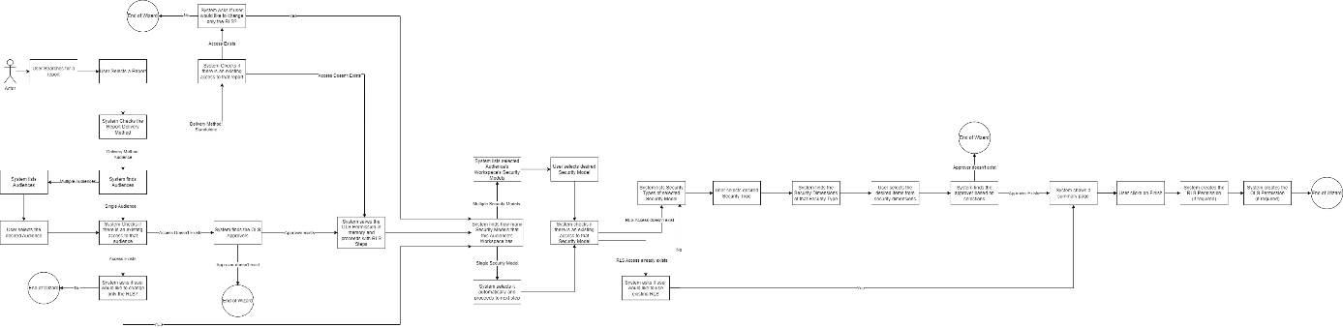
Figure 13 - Access Request Wizard – Using Report Catalog
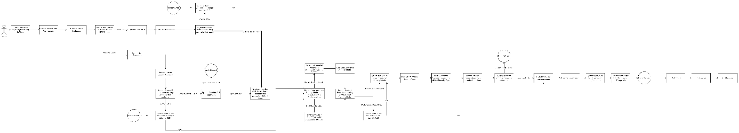
Figure 14 - Access Request Wizard – Advanced Mode

Role-Functionality Matrix
The table below outlines which functionalities in Sakura are available to which user roles. This mapping is based on the descriptions provided in section 2, where each role's capabilities are detailed. An “X” indicates that the functionality is available to the respective role.
Note: Some roles such as Sakura Support are limited to read-only access for visibility and troubleshooting purposes. Administrative actions are reserved for Workspace Admins and Sakura Administrators. Approvers act only within the approval workflow.
 | Requester | Approver | Workspace Admin | Sakura Support | Sakura Administrator
Request access for themselves | X | X | X | X | X
Request access for someone | X | X | X | X | X
View existing access of themselves | X | X | X | X | X
View existing access of someone (within their context only) |  | X | X | X | X
Viewing existing access of someone from all contexts |  |  |  | X | X
Approve Requests |  | X
Append an Approver to an existing access request |  |  | X |  | X
Approve using email |  | X
Revoke existing access |  | X | X |  | X
Delegate |  | X |  |  | X
Create or Delete a Workspace |  |  |  |  | X
View Workspaces |  |  | X | X | X
Manage Apps & Audiences in WS |  |  | X |  | X
Manage AUR in WS |  |  | X |  | X
Manage SAR in WS |  |  | X |  | X
Configure OLS Approvers |  |  | X |  | X
Administer Security Models |  |  | X
Configure RLS Approvers |  |  | X
Manage Security Dimensions |  |  |  |  | X
View Emails Sent by Sakura |  |  |  | X | X
Export Requests to Excel |  |  |  |  | X
Configure In-App Help |  |  |  |  | X
Configure System Settings |  |  |  |  | X
Manage Email Template |  |  |  |  | X

Signoff References
Here is the list of signoff references for each Workspace by owners:
DFI / FUM Workspace:
<Screenshot>
GDI Workspace:
<Screenshot>
CDI Workspace:
<Screenshot>
WFI Workspace:
<Screenshot>
AMER Workspace:
<Screenshot>
EMEA Workspace:
<Screenshot>

Check the Figure 2 - Report Delivery Scenarios. Report Delivery Method I covers the AUR and SAR is covered by Method III and Method IV.
Visual Workflow could be found here: 9.2.1 Access Request Flow
Unlike Sakura V1, in V2 it is no longer possible to submit access requests on behalf of multiple users at once. Requests must be created individually per single user. See Out of Scope Item: Creating Requests for Multiple Users (On Behalf) for more info.
These URL tags, how it should be or what it should be, aren’t clear at the moment, it will be clarified during the development phase.
For other limitations also check the Out-of-Scope part, “Approval Tree Traversing Using Multiple Security Dimensions” section.
Both RLS and OLS formats should be taken just as a sample and could be completely changed during the development phase, based on development priorities. Therefore, do not take these as final outcomes.
Items with (ROADMAP) symbol are planned for development in future versions of Sakura. While technically possible, they are not feasible to implement in the initial version due to time constraints. A roadmap outlining these plans will be shared separately.

